# Media Analysis - ChatGPT_ AI grows more powerful as we become more predictable _ Arab News

## Short Summary

The article discusses the rapid adoption of ChatGPT, an AI language model developed by OpenAI.

## Summary

Here's the summary in exactly four bullet points:  
  
1. **Adoption Rate**: ChatGPT adoption is staggering; within days, million unique users.  
2. **Predictability & AI**: OpenAI believes humans predictable enough for AI to guess our thoughts or answers.  
3. **Lack of Reasoning**: Chomsky points out that AI lacks the fundamental ability to reason like humans do.  
4. **Collaborative Future**: The truly beneficial future lies in collaboration between AI tools and human intelligence, not complete replacement.

## Question 1

The media, in framing the public discussion about ChatGPT, often employs metaphors and analogies to convey complex concepts. Some recurring metaphors include 1. **Technological disruption** Comparing ChatGPT to a wave of change or a new frontier in technology. 2. **Creative catalyst** Describing ChatGPT as a tool that enhances human creativity by generating ideas or suggestions. 3. **Balancing act** Highlighting the challenge for users, regulators, and developers to strike a balance between the benefits and risks associated with AI tools like ChatGPT. These metaphors help simplify complex discussions about AI technology, its impact on society, and the ethical considerations that arise.

## Question 2

The perspectives and aspects that are being widely covered in the context of ChatGPT s impact are 1. Adoption rate and user growth The rapid increase in users and its effect on various industries. 2. Technological capabilities and limitations Discussing how AI models like ChatGPT work, their strengths e.g., language generation , and weaknesses e.g., lack of true understanding . 3. Impact on the job market and future of work Debates about whether AI tools like ChatGPT will lead to job displacement or create new opportunities. 4. Ethics and governance concerns The discussions around privacy, bias in algorithmic decision-making, responsibility of tech companies, and regulatory frameworks. However, there are aspects that might be receiving less attention 1. Technical details beyond the basic explanation Advanced users or experts may be interested in more complex technicalities about ChatGPT s architecture or training methodology. 2. Long-term societal implications While short-term job market impacts are being covered, the long-term implications for society, culture, and human identity might not be as heavily discussed. 3. Global distribution of impact The coverage might focus on high-profile companies or industries, but a more comprehensive analysis would delve into how the adoption of ChatGPT varies across different regions, cultures, and socioeconomic backgrounds.

## Question 3

The Arabic World is not explicitly mentioned as a role in this article or their specific leverage of AI. Therefore, the answer is Not mentioned .

## Question 4

The final message is to reflect on human intelligence and its evolution with technology, while being cautious about wholesale AI integration.

## Sentiment

The sentiment is 4.0

## Entities

JOSEPH DANA, Chomsky, stu, Copyright Syndication Bureau, OpenAI, Noam Chomsky, AI, The New York Times Whereas, ibnezra lang, iPhone, Arab News, Twitter ibnezra https twitter.com, TikTok, Gmail, Joseph Dana, ChatGPT-4 https cdn.openai.com, Exponential View, Googles

## Highlights

#fb5b89#69aff0#7cc867#f9cd59

## Wordcloud for #fb5b89 Highlights

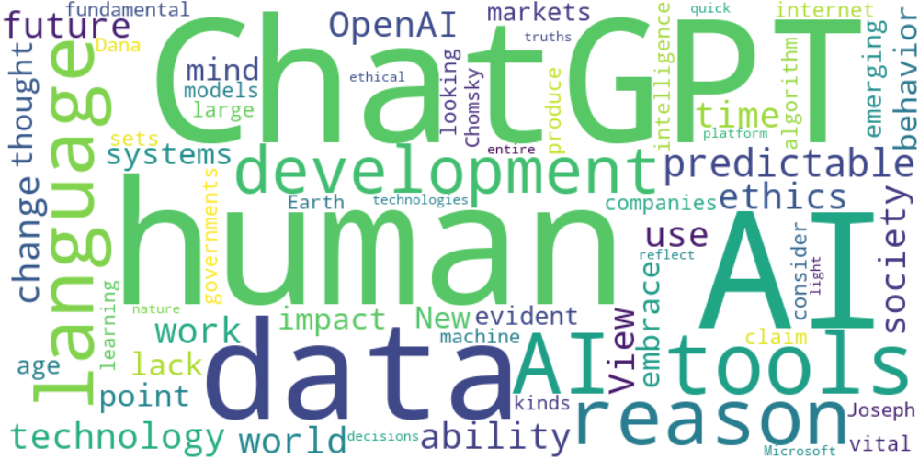

Top 10 words:

- AI: 14

- ChatGPT: 10

- human: 8

- tools: 7

- data: 6

- reason: 5

- language: 5

- predictable: 5

- future: 4

- work: 4

## Wordcloud for #69aff0 Highlights

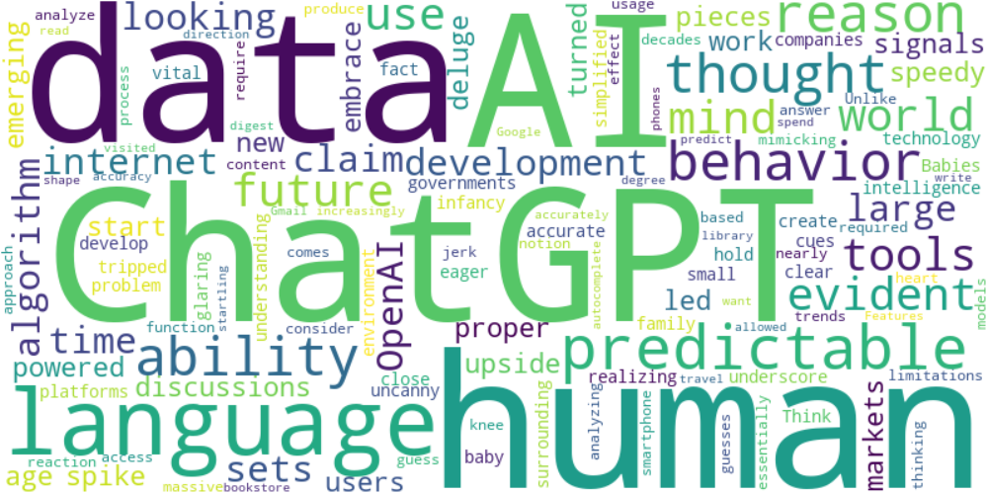

Top 10 words:

- AI: 6

- ChatGPT: 6

- data: 6

- human: 5

- language: 5

- predictable: 4

- reason: 3

- ability: 3

- behavior: 3

- thought: 2

## Wordcloud for #7cc867 Highlights

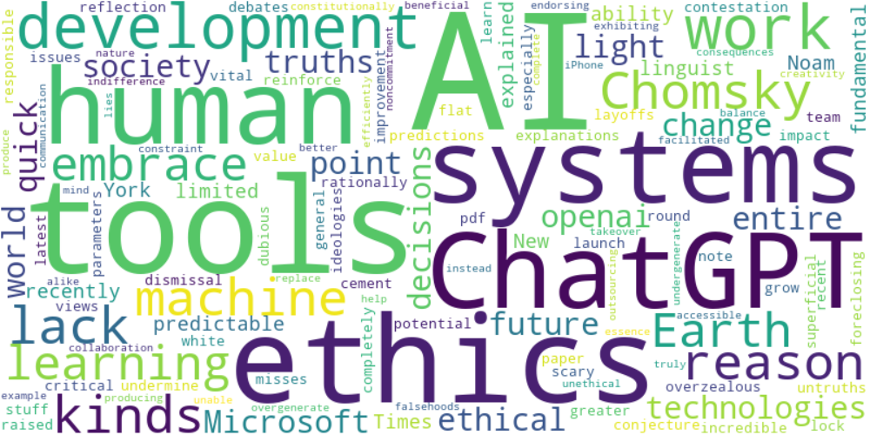

Top 10 words:

- AI: 7

- tools: 5

- ethics: 4

- systems: 3

- ChatGPT: 3

- work: 3

- lack: 2

- reason: 2

- Chomsky: 2

- kinds: 2

## Wordcloud for #f9cd59 Highlights

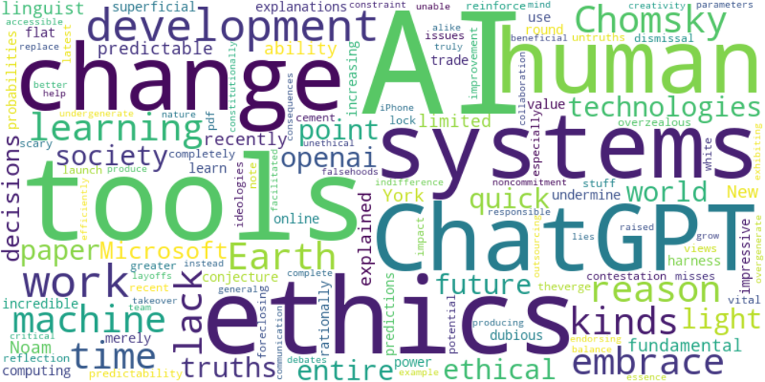

Top 10 words:

- AI: 7

- tools: 5

- ethics: 4

- systems: 3

- change: 3

- ChatGPT: 3

- work: 3

- lack: 2

- reason: 2

- Chomsky: 2